

Pizza Program in C, Lisp, Python & Java



Table of Contents

Introduction 2

C Programming Language 2

Use of C programming data structures 2

Robust input handling and programming data: 2

Discussion on implementation: Language features, Issues and Suitability. 3

Python Programming Language 3

Python Standard library 3

List mechanism 4

Discussion on implementation: Language features, issues and suitability 4

Lisp Programming Language 4

Use of recursion 4

Lists 5

Inbuilt data structures 5

Discussion on implementation: Language features, issues and suitability 5

Java Programming Language 5

Object orientation mechanism/method calls 5

Error handling 6

Standard Java libraries 6

Discussion on implementation: Language features, issues and suitability 6

Documentation and discussion of the comparative ease of implementation (design / implement / debug) in each programming language, including how robustness issues were addressed 7

Conclusion 8

Output diagrams of Pizza application 8

Output using Lisp Language 8

Output using C Language 11

Output using Python Language 13

Output using Java Language 16

# Introduction

A small program created for the pizza shop. The program developed using four different programming language such as C, Python, Java, and Lisp. Each language has a different syntax, code structure, format, readability, and writability. The choice of language depends upon the type of program to be developed. The design, implementation and debugging factors must be considered before diving into the program.

## C Programming Language

C is a simple procedural language that uses a structured approach. It consists of rich library functions, structures, array, and data types and so on. The language is flexible for breaking the program into various functions, modify and code reusability.

## Use of C programming data structures

The pizza program uses structure, enumeration (or enum), data types such as float, integer, double and char.

For handling multiple topping and pizza orders, array and char, array pointer are used. For looping, do while loop and for loop is used. For checking condition, we have utilized if-else statement, switch case and goto statement.

The program includes Macro definitions (#define directive) for constant value for use throughout the program. This syntax used for creating constants that represent numbers, strings or expressions.

**Function Declarations :** The declaration of function before the function ‘main’ is written with its function’s name, parameters used and return type. In a function declaration, only their parameter type is required. For example

void cartOrderInfo(enum Shipment type);

**Array: It is a collection of a similar data type. The elements can be inserted and deleted without any order. It uses a zero based index where each element identified by their index. When the data size is fixed then we use arrays. So, depending upon data structure requirements we used other data structure such as strings, linked lists, stack, queues, trees.**

## Robust input handling and programming data:

The pizza program is able to handle every user input. The user will be displayed informative information to console on any bad data or user errors. We have used built-in functions and operators such as switch case, goto statement, atoi, conversion from string to integer and integer to string functions for dealing with robust input handling. The program is efficient and fast due to powerful operators and functions. It is flexible enough to extend itself. The program uses ‘malloc’ for memory allocation and ‘free’ for deallocate. The array indexing checking, pizza order counting, data type checking has been done for the robustness of the program.

## Discussion on implementation: Language features, Issues and Suitability.

The C language is simple, mid-level programming language. The program written in C is fast. The program compilation and execution time is fast. The language allows the breaking of a program into several functions. This makes easy to understand and modify. The feature of dynamic memory allocation helps in allocating and de-allocating memory at any time. The program uses a feature of pointers for an array.

The issues include the function declaration before the function ‘main’ and its actual body function implementation after function ‘main’. The C language does not support object-oriented approach. Therefore, we have used ‘struct’ for handling data types and array information. For memory management, we have to deal manually with it. The use of pointer is complex and the possibility of dangling pointer issues. Debugging is a critical skill and tedious job. A lot of time and effort requires narrowing down the problem. To narrow problem, several print statements added to show how far the program gets before crashing.

The language is suitable enough for developing pizza application although the error handling is little difficult.

# Python Programming Language

Python is an interpreter, high-level programming language. It has dynamic typing and binding with build in data structures. The language is suitable for Rapid Application Development. The simple and easy syntax provides readability and reduces the cost of maintenance.

## Python Standard library

Python’s standard library contains built-in modules that provide access to system functionality such as file I/O. In this program, we have used ‘while loop’, ‘if elif’ conditional statements, arrays and ‘class’. The different ‘class’ has been created and imported on another file where required. For example:

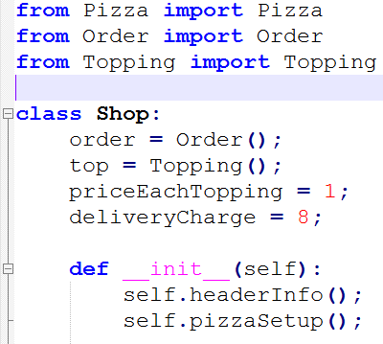

## List mechanism

Lists is the useful data types. It is a flexible collection of arbitrary objects, array. In python, it is written by enclosing a comma-separated sequence of objects in square brackets ([]). For example:

ListToping = ['foo', 'bar', 'baz', 'qux']

Index is use for accessing individual elements in square brackets. List indexing is zero-based as it is with strings.

## Discussion on implementation: Language features, issues and suitability

Python supports modules and packages. This will facilitates modularity and code reuse. The program written in Python is easy to debug and find out the bug. It supports object-oriented programming. The programs are more understandable and readable due to its expressive features.

The language does not support static type checking. Therefore, we have to carefully deal with data variables.

The language is easy to read, write and maintain. The language is flexible and supports object-oriented programming. Therefore, development is rapid and easy to debug the program. The python programs interpreted internally into byte code. Therefore, we do not need to compile it. The interpreter raises an exception to the discovery of errors. I have used a few print statements for the fast edit-test-debug cycle.

# Lisp Programming Language

Learning Lisp programming is complex. We need to be aware of computer programs.

## Use of recursion

Recursive functions call itself. While working with recursive functions, understanding of when to stop, the next step and how to call the recursive function is a must.

## Lists

The Lisp language contains built-in ‘list’ data type. This ‘lisp’ function is used for creating lists that takes any number of arguments. The basic functions for accessing the components of the list are ‘car’ and ‘cdr’. Some of the list manipulating functions are as follows:

1. car: Takes list as an argument and returns its first element.
2. cdr: Takes list as an argument and returns a list without the first element
3. cons: Takes two arguments, an element and a list and returns a list with the element inserted at the first place.
4. append: Merges two or more list into one.

## Inbuilt data structures

Common Lisp consist of rich in data types. It is a high-level language model that has garbage collection support features. The wide range data types includes objects, structures, and lists, vectors, adjustable arrays, hash-tables, and symbols.

## Discussion on implementation: Language features, issues and suitability

In Common Lisp, all data represented as objects. The Common Lisp Object System (CLOS) includes features such as multi-methods and dynamic class redefinition make it advanced object systems in the world. For the development of pizza application, we have used classes and class functions, objects, creation of arrays, lists, loops, ‘cond’ switches statements, if statements and so on.

The issues include the complex looping, guard expressions. The syntax expression are difficult to understand, read and learn the language.

The language contains consistent syntax and flexible enough to write the programs. It supports class, objects and inheritance making suitable for the developing pizza application.

# Java Programming Language

Java is a popular open-source and free programming language and used platform. It is used for various applications such as mobile applications (especially Android apps), desktop, web, games and so on. It is easy to learn and use. It is fast, secure and reliable.

## Object orientation mechanism/method calls

**The object-oriented mechanism uses the concepts of** polymorphism, inheritance, encapsulation, abstraction, class, object, method, message passing. The object encapsulates data together with functions. The functions and procedures are both called methods. The method consists of a collection of statements that perform an operation. Methods and procedures also called using their names. It may have returned value or no return value.

## Error handling

An exception or an error indicates a serious problem. Java language has a powerful mechanism to handle the exception and the runtime errors to maintain the normal flow of an application. It is able to handle checked exceptions, unchecked exceptions, exception class, and hierarchy and errors. To handle all kind of exceptions, it uses the try-catch-finally approach or with try-catch. The code written within the try block will throw an exception, which will be caught within catch blocks for handling. Then, a final block executes after successful execution of try block or catch blocks. Therefore, finally block is a good place to implement any clean up logic. Not every program is error free. Therefore, debugging support is essential for testing and finding the bugs, errors before living.

## Standard Java libraries

The file stdlib.jar bundles consist of standard libraries into a single file. While using, we must add stdlib.jar to your Java class-path. In this pizza application, we have imported below two libraries in .java class files.

import java.util.Scanner;

import java.util.ArrayList;

## Discussion on implementation: Language features, issues and suitability

The Java language supports object-oriented programming. The object consists of some data and depicts some behavior. Some of the features included are as follows:

1. Inheritance: This feature creates class hierarchies that allow structure and methods of one class passed down the hierarchy.
2. Polymorphism: The polymorphism allows an operation to takes different form and behavior in different instances. The behavior depends upon the data types used in the parameter.
3. Encapsulation: Encapsulation helps to protect data from the outside world.
4. Support for abstraction: The protection of data from direct access by the program and complexity hiding is very important. Hiding the complexity of program and implementation details from the user provides security and protection of data.

The pizza program uses class, encapsulation, polymorphism and objects concepts.

The program is small and the issues are very negligence. We need to focus on the design and overall flow of program sequences.

The program development using Java takes a lot of time and needs to write more coding.

The program is written in Java could be used anywhere which is the important features of Java language i.e. called portability. It runs on any device. Thus, a programmer does not have to worry about the changing hardware or operating system. Similarly, the program does not have to worry about memory management. The Java language features automatically maintain reliability.

# Documentation and discussion of the comparative ease of implementation (design / implement / debug) in each programming language, including how robustness issues were addressed

The pizza program developed in four different programming languages such as C, Python, Lisp, and Java language. The languages are procedural, functional and object-oriented. The languages are mid-level and high-level programming language. The comparison in terms of robustness, Java is the most suitable language. Java creates reliable software. It is flexible and easily maintained style makes software construction, compilation, and error checking much faster. Its performance level is high when it comes to the overall cost. The language is reliable in terms of handling the exception, the portable, cross-platform support, multithreading, internal data correctness checking and so on. The design and implementation of the program using java language are robust, fault tolerance, flexible, and dynamic and object-oriented.

On the other hand, python programs take less time for implementation but run slower than Java. It supports built-in high-level data types and dynamic typing. It has to inspect the objects to find out type during run time. On the other hand, Java supports static type checking. Developing programs using Java consumes more time. It is a low-level implementation language whereas python can be used for rapid application development i.e. prototype.

Similarly, the same applies to the C. Python code is typically 3-5 times shorter than Java code and 5-10 times shorter than C code. Each language has cons and pros. It depends upon the type of projects or programs that are going to develop depending upon one need to choose the supporting.

# Conclusion

The support of debugging is essential for testing and finding the bugs, errors before living. Finding the error, problems in C, Lisp and Python are time-consuming. It takes lots of time locating the exact point of error.

In conclusion, Java language is easy for design, implementation and debugging.

# Output diagrams of Pizza application

## Output using Lisp Language

For running the Lisp program, you need to set up the environment. The steps include:

1. Download the CLISP from <https://sourceforge.net/projects/clisp/>
2. CLISP is automatically added to our path variable on the selection of option (RECOMMENDED).
3. Now open the Command Prompt window and go to the directory where your lisp program file is located.
4. To run a lisp program: clisp hellow.lisp

Fig1: Pizza application menu options using Lisp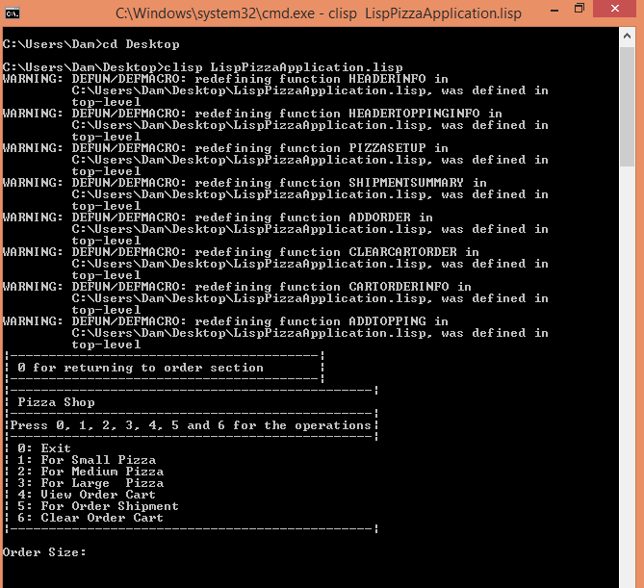

Fig2: Topping options available for pizza application using Lisp

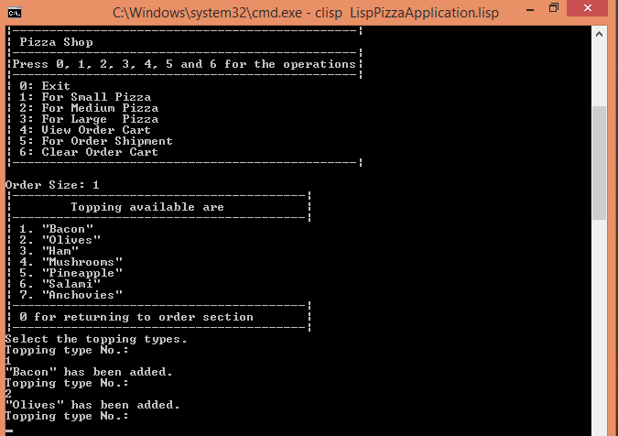

Fig3: Order shipment options for user using Lisp

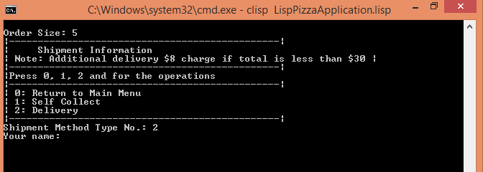

Fig4: Order completion receipt for user using Lisp

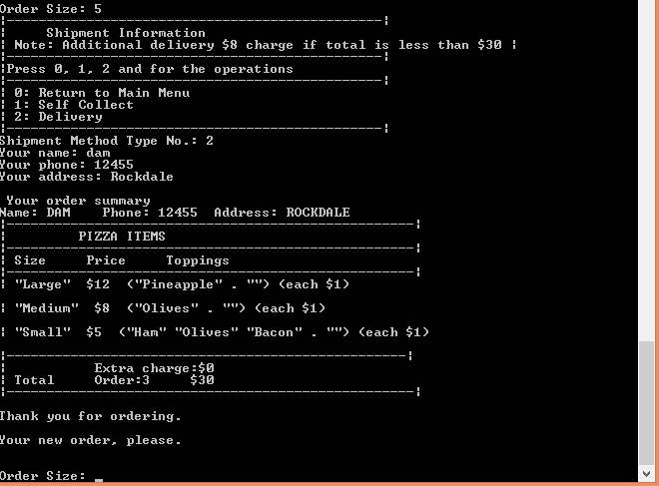

## Output using C Language

Fig1: Pizza application menu options using C

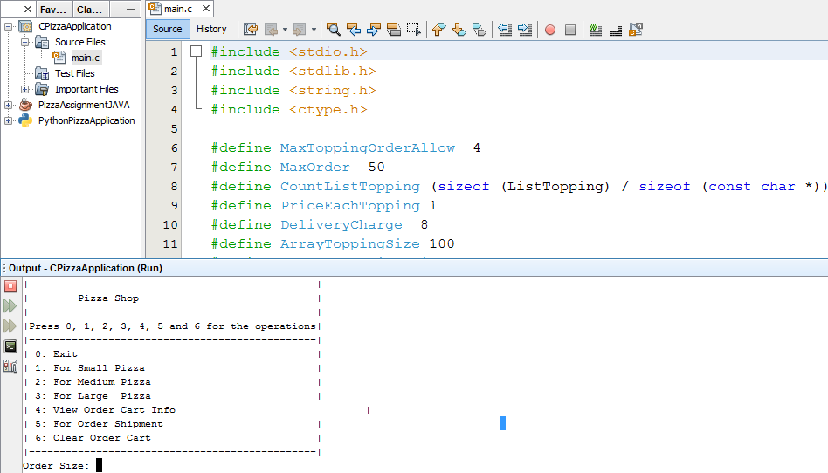

Fig2: Topping options available for pizza application using C

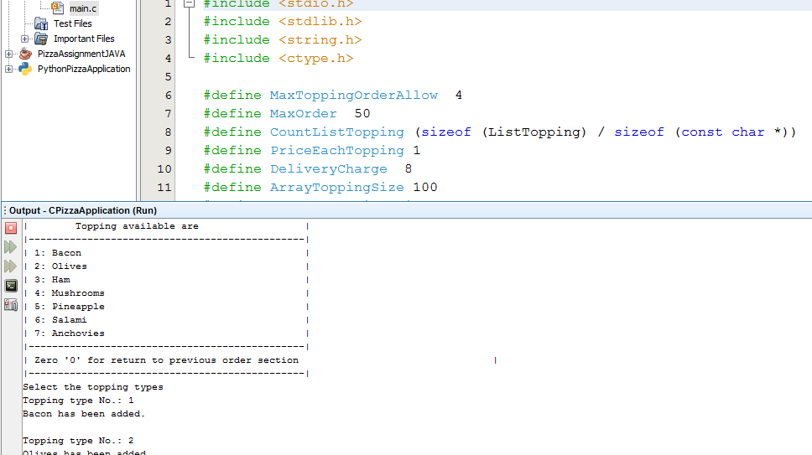

Fig3: Order shipment options for user using C

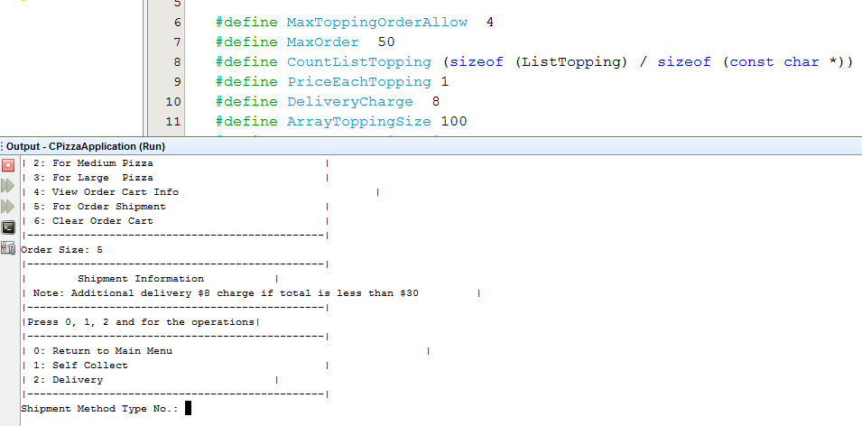

Fig4: Order completion receipt for user using C

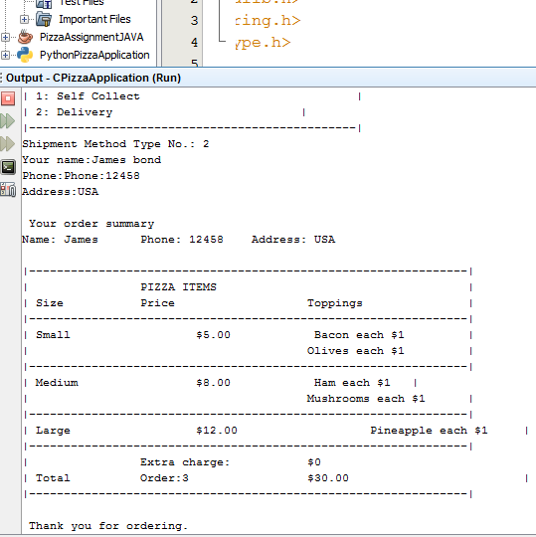

## Output using Python Language

Fig1: Pizza application menu options using Python

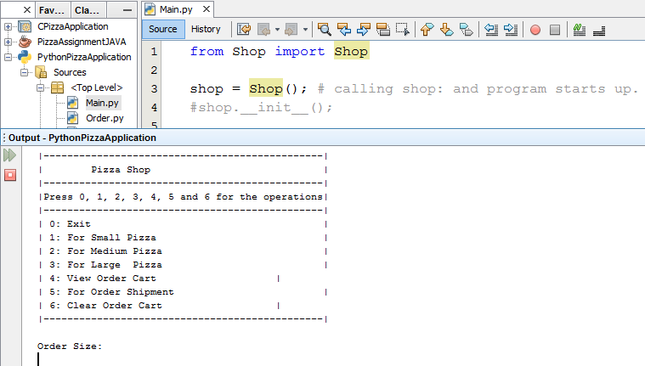

Fig2: Topping options available for pizza application using Python

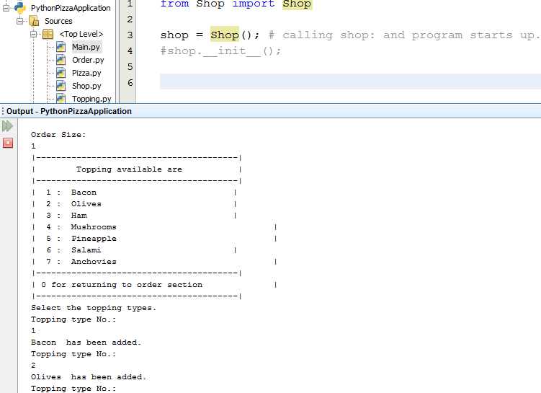

Fig3: Order shipment options for user using Python

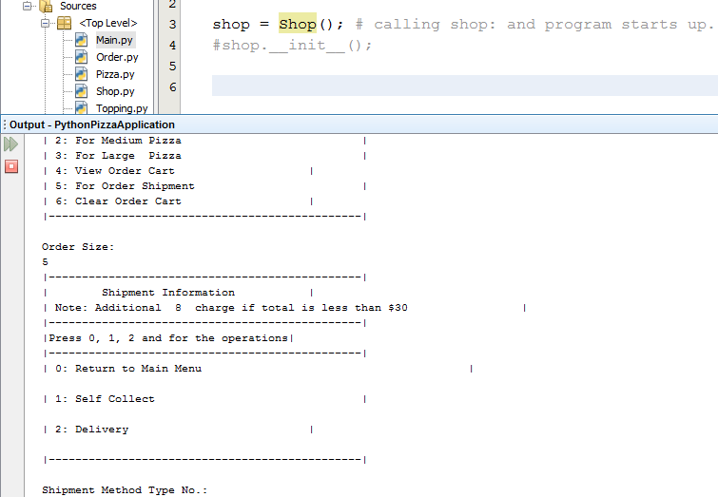

Fig4: Order completion receipt for user using Python

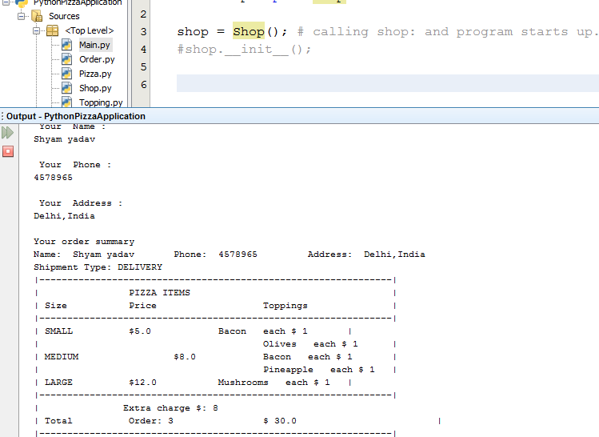

## Output using Java Language

Fig1: Pizza application menu options using Java

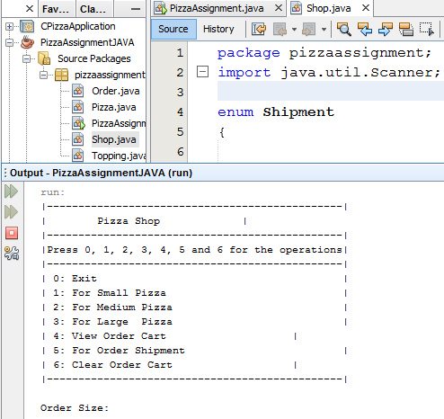

Fig2: Topping options available for pizza application using Java

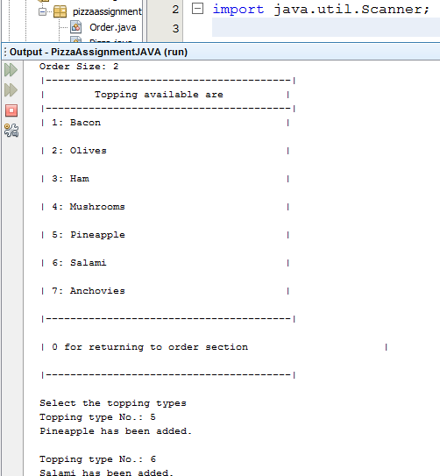

Fig3: Order shipment options for user using Java

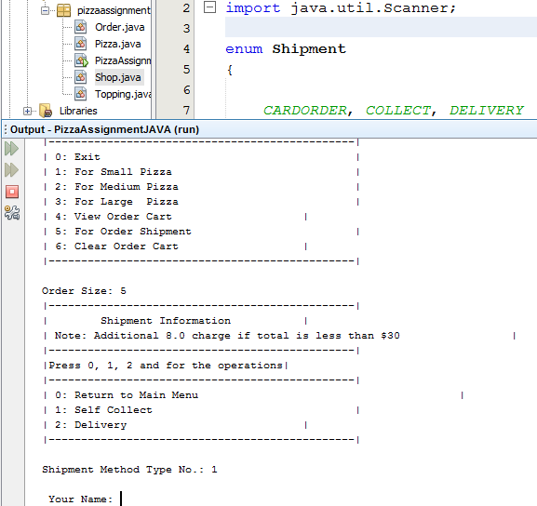

Fig4: Order completion receipt for user using Java

